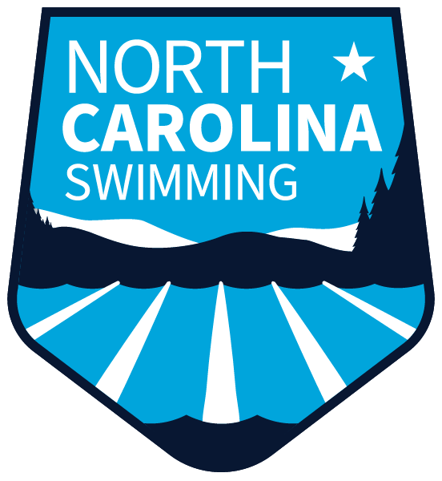
Leading the nation in development, diversity, achievement, and citizenship, in and out of the water.
Enriching the competitive swimming experience in North Carolina with resources, programming, and leadership.

https://swimnc.com/2021-ncs-fall-hod/

MEETING AGENDA
Fall House of Delegates
Sunday October 3, 2021, 1:00 PM
In Person meeting at NCSU McKimmon Center and/or Virtual Meeting on ZOOM

- Call to Order – Trish Martin

- Roll Call – Jamie Bloom

- Reading, correction, and adoption of minutes – Jamie Bloom

- Officer/Coordinator/Committee Reports
  - General Chair–Trish Martin
  - Treasurer–Jon Fox
  - Finance Vice-Chair– Lisa Olack–Approval of 2021-2022 Budget
  - Scheduling–Kevin Thornton–Approval of 2022 LC Meet Schedule
  - Safe Sport–Claire Donahue White
  - Officials Committee–John Jewell
  - Athlete Committee–Jack Nowacek

- BOD Elections–Chris Hoover
- Legislation–Wayne Shulby
- New Business

- Upcoming LSC Events
  - November 7, 2021 New “A Team” Clinic
  - January 22 or 23, 2022 IMX Camp
  - February 17 and 24, 2022 NCS SC AG and SR Champs in Greensboro
  - April 2022 Select Camp
  - April 9-10, 2022 Spring HOD
  - April 23, 2022 Carolina Crown

- Coach Education Raffle

- Adjournment

